UNIT 4
Lesson 1 – IT'S MONDAY AGAIN
- 1 a) Circle the days of the week.
Zaokruži riječi za dane u tjednu.
Monday May Friday June Tuesday Thursday January Wednesday Sunday March Saturday

b) Write the days of the week on the empty line:
Ispiši dane u tjednu na praznu crtu.
_________________________________________________
_________________________________________________
_________________________________________________

c) Match the days of the week in Croatian and English.
Spoji dane u tjednu na hrvatskom i engleskom jeziku.

1 Monday Utorak
2 Tuesday Ponedjeljak
3 Wednesday Četvrtak
4 Thursday Nedjelja
5 Friday Petak
6 Saturday Subota
7 Sunday Srijeda

d) Put the days of the week in order.
Posloži dane u tjednu po redu.
Monday Tuesday Thursday Sunday Saturday Wednesday

1 Monday
2 _____________________
3 _____________________
4______________________
5______________________
6______________________
7______________________

e) Circle the weekend days purple.
Koji su dani vikend? Zaokruži ih ljubičastom bojom.
f) Listen  to the tongue twisters (track 4.1).
What days of the week do you hear?
Poslušaj snimku brzalica (zapis 4.1.).
Koje dane u tjednu čuješ na snimci?
g) Listen to the tongue twisters (track 4.1) once again.
Write the missing words. Find help in the frame.
Poslušaj snimku brzalica (zapis 4.1) još jednom.
Na prazne crte upiši imena dana koji nedostaju.
U okviru su ponuđene riječi.
Monday Tuesday Thursday Sunday Saturday Wednesday

Miserably moody __________________ ,
Terribly tough __________________ ,
Well-wishing __________________ ,
Tricky troublesome __________________ ,
Fantastically friendly __________________ ,
Superbly splendid __________________ ,
Sweet slow _______________ .

h) Choose one tongue twister (sentence) in task 1 f)
and try to say it fast.
Izaberi jednu brzalicu iz zadatka 1 f). Probaj ju brzo izgovoriti.
i) How do you feel on different days od the week?
Kako se osjećaš na različite dane u tjednu?

How do you feel each day? Pick the emoticons.
Cut them and glue them under the correct day.
Kako se osjećaš različitih dana u tjednu. Izaberi emoticon.
Izreži ih i zalijepi ispod naziva za određeni dan.

happy  sretno | happy  sretno | OK  OK   | OK  OK | pleased  zadovoljno  
pleased  zadovoljno | bad  loše  | bad  loše | mad  ljuto  | mad  ljuto
sad  tužno | sad  tužno | (moj primjer) | (moj primjer) | (moj primjer)

Monday | Tuesday | Wednesday | Thursday | Friday | Saturday | Sunday

j) Complete the sentences.
Use answers from task 1 h).
Dovrši rečenice odgovorima iz zadatka 1h).

1 I feel ______________________ on __________________ .
(upiši kako se osjećaš) (upiši na koji dan)
2 I feel ______________________ on __________________ .

3 I feel ______________________ on __________________ .

4 I feel ______________________ on __________________ .

5 I feel ______________________ on __________________ .

6 I feel ______________________ on __________________ .

7 I feel ______________________ on __________________ .

k) Have you got a favourite day of the week?
How do you feel on that day? Why?
Imaš li omiljeni dan u tjednu?
Kako se osjećaš na taj dan? Zašto?

My favourite day of the week is ______________________ .
Moj omiljeni dan u tjednu je

I feel _______________________________ because
Osjećam se zato što
_________________________________________ .

- 2 a) Look at the pictures. Read the expressions below.
Pogledaj sličice. Pročitaj izraze ispod sličica.


be good at something
biti dobar u nečemu


social life
društveni život


far away
daleko

hang out
družiti se / provoditi vrijeme skupa

b) Find the correct word from task 2 b).
Complete the sentences.
Dopuni rečenice riječima iz 2 b) zadatka.

1 The activities that you do and the time you spend with
other people is __________________________.
Aktivnosti koje obavljaš i vrijeme koje provodiš zajedno s drugim
ljudima naziva se…

2 When you spend a lot of time with your friends,
you __________________________ with them a lot.
Kada provodiš vrijeme sa svojim prijateljima kažeš da…

3 When you are not near, you are _______________ .
Kada nisi blizu, onda si…

4 When a person is able to do something very well,
he / she is ____________________ .
Kada je osoba nešto jako dobro radi kažemo da je…
- 3 a) Read the text about Penelope.
What is her favourite day of the week? Why?
Pročitaj tekst o Penelope.
Koji je njezin omiljeni dan u tjednu? Zašto.
PENELOPE
Penelope: My favourite day is Friday.
Moj omiljeni dan u tjednu je petak.

I like Fridays after 11.30.
Volim petke u 11:30 sati.

That’s the end of geography lesson and
the beginning of IT class.
Tada je kraj sata geografije i početak sata informatike.

I like IT and I’m good at it.
Volim informatiku i dobro mi ide.

I often finish all of the tasks first.
Često prva dovršim svoje zadatke.

My teacher lets me play computer games then.
Moj učitelj dozvoli mi igrati igre na računalu.
After school I spend time with my friends.
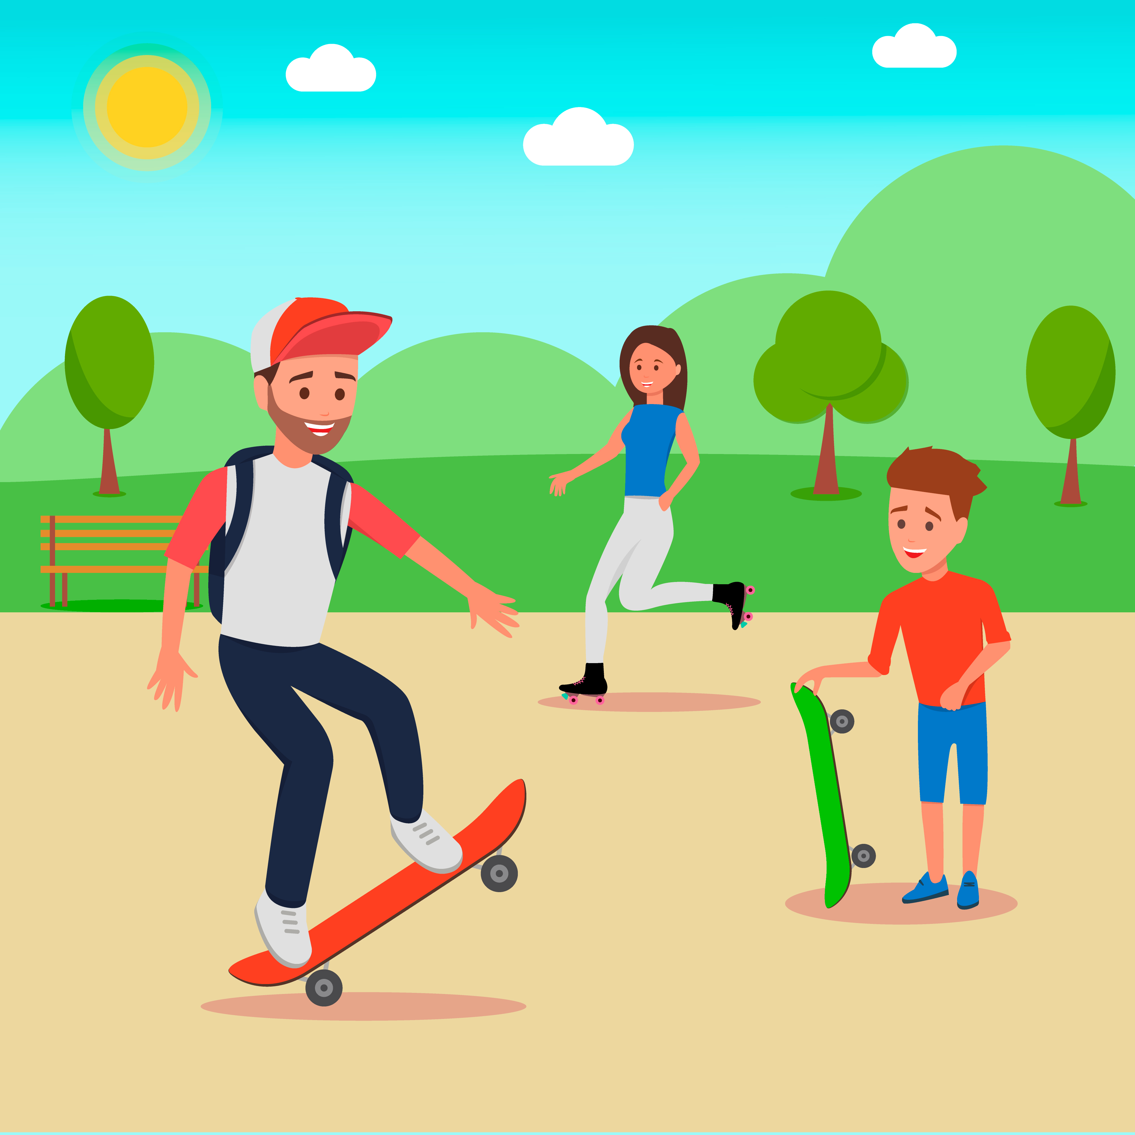
Nakon škole provodim vrijeme se sa svojim prijeteljima.
We hang out in the park.
Družimo se u parku.

That’s the beginning of my weekend.
Takav je početak mog vikenda.

b) What is Peneope's favourite day?
Koji je Penelopin omiljeni dan?
Penelope's favourite day is ________________________.
Penelopin omiljeni dan je…

c) Read the text about Ollie.
What is his favourite day of the week? Why?
Pročitaj tekst o Olliju. Koji je njegov omiljeni dan. Zašto?
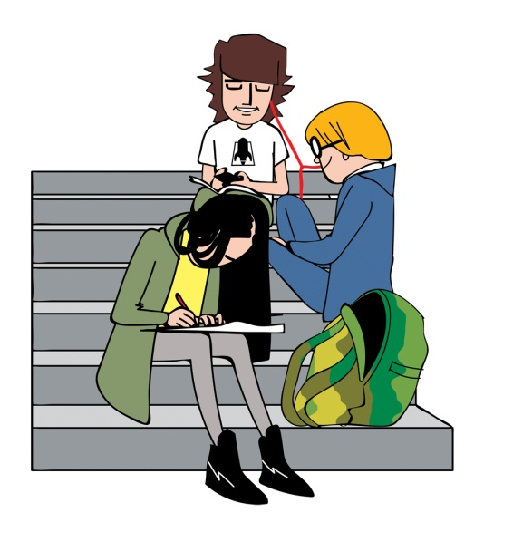OLLIE
Ollie: My favourite day is Monday.
Moj omijeni dan je ponedjeljak.
I like going to school. No, I’m not crazy.
Volim ići u školu. Ne, nisam lud.

My social life  is at school.
Moj društveni život dešava se u školi.
I see my friends there.
Tamo se sastajem sa svojim prijateljima.
I also like my teachers because they help me.

Volim i svoje učitelje jer mi pomažu.

I travel a lot for my skiing practice.
Često putujem zbog skijaških priprema.

Sometimes I’m not at school for weeks.
Ponekad me tjednima nema u školi.

When I come back, I take tests.
Kada se vratim, pišem testove.
I like hanging out  with my friends
and going to school like a normal teenager.
Volim se družiti sa svojim prijateljima i ići u školu kao običan tinejdžer.

d) What is Ollie's favourite day?
Koji je Ollijev omiljeni dan?
Ollie's favourite day is _________________________ .
Ollijev omiljeni dan je

e) Do you like Monday or Friday better? Why?
Koji ti je draži dan u tjednu. ponedjeljak ili petak? Zašto?

I like________________ better because _______________
Volim više, zato što
________________________________________________ .

f) Read both texts again.
Answer the questions about Ollie or Penelope.
Write Ollie or Penelope on the empty lines.
Pročitaj oba teksta još jednom. Odgovori na pitanja o Penelope i Olliju.
Na prazne crte upiši Ollie ili Penelope.

1 Who likes going to school? Ollie
Tko voli školu?
2 Who likes weekends? ____________
Tko voli vikende?
3 Who travels a lot? ____________
Tko često putuje?
4 Who spends time with their friends after school? ________
Tko provodi vrijeme poslije škole s prijateljima?
5 Who gets help from the teachers? ____________
Kome pomažu učitelji?
4 a) Answer these questions about yourself.
Circle the correct answers.
Odgovori na ova pitanja o sebi. Zaokruži točan odgovor.

1 Do you like school? Yes, I do. / No, I don't.
Voliš li školu? Da, volim. / Ne, ne volim.
2 Do you go to school by car? Yes, I do. / No, I don't.
Ideš li u školu autom? Da, idem. / Ne, ne idem..
3 Do you like weekends? Yes, I do. / No, I don't.
Voliš li vikende? Da, volim. / Ne, ne volim.
4 Do you spend time with your friends after school?
Yes, I do. / No, I don't.
Provodiš li vrijeme poslije škole s prijateljima?
Da, provodim. / Ne, ne provodim.

5 Do you live near the school? Yes, I do. / No, I don't.
Živiš li blizu škole? Da, živim. / Ne, ne živim.
6 Do you like geography? Yes, I do. / No, I don't.
Voliš li geografiju? Da, volim. / Ne, ne volim.

b) Use your answers to make sentences about yourself.
Example: I like school. / I don't go to school by car.
Upotrijebi odgovore iz zadatka 4 a).
Na prazne crte napiši rečenice o sebi.

1 I ____________________________________________
2 _____________________________________________
3 ____________________________________________
4 ____________________________________________
5_____________________________________________
6 ____________________________________________

c) Ask your friend the same questions from task 4 a).
Circle the correct answer.
Pitaj ista pitanja ( zadatak 4 a)) svog prijatelja iz razreda.
Zaokruži točan odgovor.

1 Does he / she like school?
Yes, he / she does. No, he / she doesn't.

2 Does he / she go to school by car?
Yes, he / she does. No, he / she doesn't.

3 Does he / she like weekends?
Yes, he / she does. No, he / she doesn't.

4 Does he / she spend time with your friends after school?
Yes, he / she does. No, he / she doesn't.

5 Does he / she live near the school?
Yes, he / she does. No, he / she doesn't.

6 Does he / she like geography?
Yes, he / she does. No, he / she doesn't.

